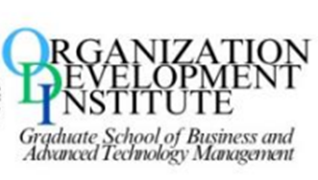
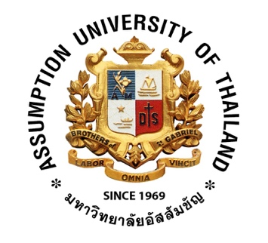


ABAC ODI JOURNAL Vision. Action. Outcome

ISSN: 2351-0617 (print), ISSN: 2408-2058 (electronic)

Exploring Employee Perceptions of Best Practices that Support
Long-Term Retention in a Foreign-Invested Manufacturing Company
in Thailand

Gengjia Zhang

ABAC ODI JOURNAL Vision. Action. Outcome Vol 13(3) pp. 97-120

https://assumptionjournal.au.edu/index.php/odijournal

Published by the
Organization Development Institute
Graduate School of Business and Advanced Technology Management
Assumption University Thailand

ABAC ODI JOURNAL Vision. Action. Outcome
is indexed by the Thai Citation Index and ASEAN Citation Index

Exploring Employee Perceptions of Best Practices That Support Long-Term Retention in a Foreign-Invested Manufacturing Company in Thailand

Gengjia Zhang¹

¹Masters of Management in Organization and Development (MMOD)
Graduate School of Business and Advanced Technology Management (GS-BATM),
Assumption University, Thailand. Email: gengjiazh@gmail.com

Received: 31 August 2025. Revised: 20 September 2025. Accepted: 29 September 2025

Abstract

This study explores determinants influencing long-term employee retention at Hong Zin Tai Industry Company Limited in Thailand. Using Organizational Support Theory, Social Exchange Theory, and Herzberg’s Two-Factor Theory, the research examines how workplace practices, leadership styles, compensation, and workload management impact production workers' intention to stay. Data from interviews with eight employees were analyzed using the Appreciative Inquiry 5D framework and SOAR analysis. Results show that perceived organizational support, approachable leadership, fair compensation, and manageable workloads are key factors in retention. Employees placed less emphasis on career development, highlighting a gap between theory and practice. Retention priorities change over the employee lifecycle, with newcomers valuing integration, mid-tenure staff seeking fairness, and long-tenured employees valuing stability and relationships. Effective retention strategies in small manufacturing settings should focus on tangible support, organizational care, and consistent leadership, while reevaluating development pathways. These findings contribute to HR management in foreign-invested manufacturing enterprises, highlighting the importance of adaptable retention approaches.
Keywords: Perceived Organizational Support, Compensation, Workload, Leadership Style, Career Development, Employee’s Long-term Retention

Introduction

Employee retention is a central HR challenge in manufacturing, particularly in foreign-invested firms in Thailand. Frontline production workers hold critical operational knowledge, and their continuity directly affects quality, throughput, and delivery reliability. When experienced operators leave, firms incur hiring and training costs and face workflow disruptions and weaker team cohesion. Understanding why production workers stay is thus vital for performance and stability.
Retention is especially important on the production floor, where task familiarity, tacit know-how, and teamwork develop over time. The company’s owner emphasizes long-term retention of production workers, who form the majority of the workforce and anchor daily output. Yet, the firm has never systematically tracked turnover or assessed employee commitment, leaving uncertainty about satisfaction and retention intentions. To address this gap, the study applies three theoretical lenses. Organizational Support Theory (Eisenberger et al., 1986) explains how fairness, supervisor care, and workplace support encourage loyalty. Social Exchange Theory (Blau, 1964; Cropanzano & Mitchell, 2005) shows how reciprocal exchanges, where employees feel valued, build sustained commitment. Herzberg’s Two-Factor Theory (Herzberg, 1968) distinguishes between hygiene factors (salary, security) that prevent dissatisfaction and motivators (recognition, growth) that strengthen engagement. Together, these frameworks guide analysis of how compensation, workload, organizational support, leadership, and career development influence production workers’ intention to remain.

Company background
This study focuses on Hong Zin Tai Industry Company Limited, a Taiwanese-owned pencil manufacturing company in Thailand. The factory has a production department responsible for core processes from material preparation to packing, with a predominantly Thai workforce of front-line production workers. Management has improved the physical environment and facilities but recognizes the need for a strong retention strategy for long-term stability. Established in May 2013, Hong Zin Tai serves domestic and international markets with around 40 staff members. As a small player in the competitive pencil manufacturing industry, the company places high importance on retaining its workforce to ensure quality output and business reliability. To achieve this, the company aims to balance global best practices with local expectations by offering competitive compensation, supportive leadership, manageable workloads, and clear career development pathways. Effective retention is crucial for daily productivity and long-term growth, enhancing the company's reputation in the global market.

Need for the Research
This study arises from the owner’s recognition that human resources are critical to organizational success. Although Hong Zin Tai Industry Company Limited has emphasized operations and market adaptation, it has not systematically assessed workforce needs, tracked turnover, or examined employee commitment. This gap limits understanding of whether production workers are satisfied or likely to remain long-term.
Addressing this issue, the study clarifies what motivates production employees to stay and how workplace practices can support retention. It highlights structural and relational factors such as leadership trust, workload balance, career development, and organizational support, moving beyond job satisfaction to advance retention research in foreign direct investment manufacturing. By situating the inquiry in a small, foreign-invested firm in Thailand, the study adds contextual specificity to Southeast Asian literature and offers comparative value across industries and ownership types.
Practically, the findings provide HR practitioners and organizational leaders with actionable strategies that integrate competitive compensation, fair workload distribution, transparent communication, and career growth opportunities. Insights from the SOAR analysis connect internal strengths with marketplace opportunities and guide strategies for long-term competitiveness. At a societal level, effective retention reduces recruitment costs, sustains production continuity, and enhances regional economic resilience.

SOAR Analysis
The SOAR analysis, based on an interview with the owner of Hong Zin Tai Industry Company Limited and supported by workplace observations, highlighted key organizational strengths, aspirations, opportunities, and results.
Strengths
The company’s core strengths lie in its diverse and skilled workforce, which fosters collaboration, problem-solving, and adaptability on the production floor. Competitive compensation, attendance bonuses, health insurance, and welfare packages provide employees with financial security and recognition, reinforcing loyalty and long-term commitment, which reassures employees about future stability.
Opportunities
Externally, Thailand’s Industry 4.0 initiative and government incentives (BOI and IEAT) create opportunities for digital transformation, automation, and workforce upskilling. Growing demand for sustainable and eco-friendly products also opens new business channels. Demographic shifts, including a younger labor force, provide a long-term talent pipeline. Internally, the company can strengthen employee engagement by improving transparency in performance management and applying workforce analytics to better align HR and business strategies.
Aspirations
Building on these strengths and opportunities, management aspires to position Hong Zin Tai as a future-ready employer of choice. The vision is to create a workplace where employees feel valued, supported, and motivated to grow with the organization. This includes a culture of well-being, stress management, and work-life balance, as well as structured training, mentorship, and career development aligned with Industry 4.0 skills.
Results
Success will be measured by lower voluntary turnover, signaling stronger satisfaction and commitment. Beyond workforce stability, leadership aims for sustainable business growth through revenue expansion, customer trust, and long-term social responsibility. The envisioned results rest on balancing profitability with employee well-being, ensuring sustainable outcomes for all stakeholders.

Possibility statement
This study is based on the belief that Hong Zin Tai Industry Company Limited already possesses internal strengths and aspirational goals that can serve as a foundation for long-term employee retention. Rather than approaching the issue from a problem-oriented perspective, the research begins with the possibility that the organization can become a workplace where employees not only stay but thrive.
The possibility is that through a deeper understanding of what employees truly value, such as high compensation, supportive leadership, meaningful recognition, growth opportunities, and a culture of care, the company can intentionally shape a work environment that naturally promotes long-term commitment and belonging among its production workforces.

Research Objectives
1. To explore how Thai production workers at Hong Zin Tai Industry Company Limited perceive the best practices that support their long-term commitment and intention to stay.
2. To examine whether the organizational aspirations identified by management align with what employees consider meaningful for long-term retention.

Research Questions
1. What workplace practices do Thai production workers at Hong Zin Tai Industry Company Limited perceive as meaningful and supportive of their long-term retention?
2. To what extent do the aspirations expressed by company management align with the actual perceptions of employees regarding long-term commitment and belonging?

Literature Review

Organizational Support Theory (OST)
Organizational Support Theory (OST) holds that employees form beliefs about how much their organization values their contributions and cares for their well-being (Eisenberger et al., 1986; Rhoades & Eisenberger, 2002). This perception, termed Perceived Organizational Support (POS), arises from fairness, supervisor support, and favorable conditions, fulfilling socio-emotional needs and fostering commitment, loyalty, and performance while reducing turnover (Kurtessis et al., 2017). That evidence confirms OST as a strong predictor of engagement and retention across sectors. In manufacturing, fair compensation and balanced workload represent justice, leadership reflects supervisor support, and career development signals organizational investment. These elements shape OST, which strengthens employee attachment and reduces voluntary turnover, making OST a suitable foundation for this study of Hong Zin Tai’s production workforce.

Social Exchange Theory (SET)
Social Exchange Theory (SET) explains that individuals maintain relationships based on the perceived balance between costs and benefits, guided by the norm of reciprocity (Blau, 1964; Cropanzano & Mitchell, 2005). In organizational settings, when employers provide valuable resources such as fair pay, advancement opportunities, emotional support, and constructive feedback, employees feel obligated to reciprocate through positive attitudes, stronger performance, and sustained commitment. This reciprocal process helps create climates of fairness, respect, and trust that reinforce the psychological contract and encourage long-term retention. Empirical research confirms SET as a robust framework for understanding retention across cultural and industrial contexts (Xuecheng et al., 2022). In this study, SET provides a lens for interpreting how leadership, organizational support, and career development shape employees’ decisions to remain with Hong Zin Tai Industry Company Limited.

Herzberg’s Two-Factor Theory of Motivation
Herzberg’s Two-Factor Theory (Herzberg, 1968) distinguishes between hygiene factors, such as salary, job security, workplace safety, and interpersonal relations, which prevent dissatisfaction, and motivators such as achievement, recognition, responsibility, and growth, which generate satisfaction and long-term commitment (Nickerson, 2025). In the context of this study, production workers in a foreign-invested Thai manufacturer emphasized hygiene factors, including fair pay, safe conditions, supportive supervision, and welfare, as essential for retention. Their absence was viewed as a direct cause of dissatisfaction and turnover, consistent with Herzberg’s model. Supporting this, the researchers (Haddad et al., 2023) found that hygiene factors provide security but do not foster deep engagement, while motivators were less evident.

Figure 1

Herzberg’s Motivation - Hygiene Theory

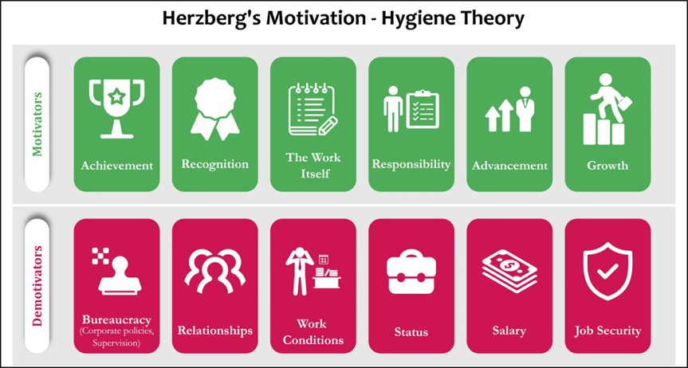
Figure 1 shows that Herzberg’s Motivation-Hygiene Theory, which differentiates between factors that intrinsically motivate employees and those that merely prevent dissatisfaction. The “motivators” (e.g., achievement, recognition, the nature of the work, responsibility, advancement, and growth) are linked to deeper engagement and a sustained desire to remain with the organization. In contrast, the “hygiene factors” (e.g., organizational processes, interpersonal relationships, work conditions, compensation, and job security) are essential for creating a stable and acceptable work environment, yet their presence alone does not ensure long-term commitment.

Appreciative Inquiry (5Ds)
Appreciative Inquiry (AI) is a strengths-based, collaborative approach to organizational development that seeks to identify, amplify, and build upon factors contributing to organizational success, rather than concentrating exclusively on problems or deficits. Developed by Cooperrider and Whitney (2005), AI is rooted in the premise that organizations evolve toward the questions they consistently and systematically ask. This sociorationalist methodology emphasizes the power of positive dialogue, asserting that reality in organizations is socially constructed through inquiry and conversation.
Central to AI is the belief that engaging participants in reflective, affirmative dialogue enables the co-creation of strategies aligned with shared aspirations. The process fosters collective ownership, energizes change efforts, and cultivates a focus on organizational potential rather than limitations. Bushe and Kassam (2005) further underscore that AI represents a transformational non-deficit approach to change, embracing the polarities and &generative tensions that fuel organizational vitality (Bushe & Kassam, 2005).

Factors Considered in This Study

Compensation
Compensation is consistently identified as a foundation of retention. Tangthong et al. (2014) showed that competitive packages in Thai manufacturing improved retention even without strong engagement programs, suggesting that financial rewards alone can sustain stability. However, Herzberg’s Two-Factor Theory (1968) argues that pay functions primarily as a hygiene factor, preventing dissatisfaction but not fostering deeper motivation. This contrast indicates that while compensation can directly reduce turnover, its long-term impact depends on whether it is paired with motivators such as recognition or growth opportunities.
Figure 2

Conceptual Model of HRM Practices and Employee Retention in Thailand

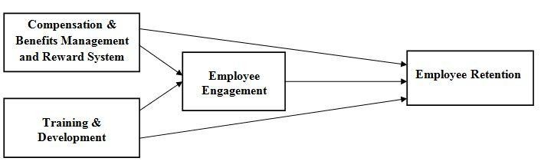
Note: From HRM practices and employee retention in Thailand (Tangthong et al., 2014).

Workload
Workload was another important influence on employees’ decision to stay. Aqilah et al. (2023) showed that excessive demands increase turnover intention and weaken commitment. In this study’s context, employees clearly valued predictable and reasonable workloads, which allowed them to work effectively without burnout. This finding can be read through Herzberg’s Two-Factor Theory, where manageable workloads function as hygiene factors that prevent dissatisfaction. At the same time, when employees see that tasks are fairly distributed, it signals organizational care (Eisenberger et al., 1986) and strengthens reciprocity in the employer-employee relationship (Blau, 1964; Cropanzano & Mitchell, 2005).

Figure 3

Conceptual Model of the effects of perceived work overload on organizational commitment on employee turnover intention in automotive industry in Pahang.
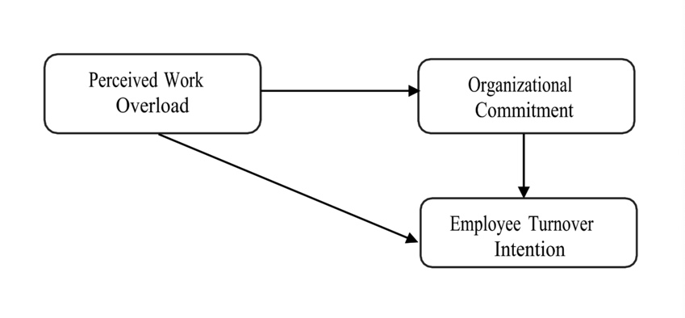
Note: Figure from The effects of perceived work overload on organizational commitment on employee turnover intention in automotive industry in Pahang (Aqilah et al., 2023).

Leadership Style
Leadership quality influences both satisfaction and long-term loyalty. Feungarrom and Tantasanee (2025) showed that fairness, communication, and care reduced turnover risk, while favoritism heightened dissatisfaction. These findings echo Organizational Support Theory, where fair treatment enhances perceived support, and Social Exchange Theory (Blau, 1964; Cropanzano & Mitchell, 2005), where respectful leadership elicits reciprocity. While Herzberg would classify leadership as a hygiene factor that prevents dissatisfaction, evidence suggests it can also act as a motivator when leaders provide individualized support and coaching. This dual role highlights leadership as both a baseline necessity and a potential driver of deeper engagement.

Career Development
Career development is widely recognized in retention literature as an important factor, yet it appeared far less prominent in this study. Feungarrom and Tantasanee (2025) observed that unclear promotion pathways created dissatisfaction, while Allen et al. (2003) argued that structured development is a strategic tool for sustaining long-term commitment. Herzberg (1968) also positions career growth as a motivator that can generate satisfaction when present, although its absence does not always result in immediate turnover. The findings here suggest a contextual nuance: while theory consistently highlights career development as a cornerstone of retention, production workers in this study placed greater emphasis on stability, fairness, and supportive conditions. In such environments, opportunities for advancement may only become meaningful once these more immediate needs, compensation, manageable workload, and organizational support are firmly met.

Figure 4

Conceptual Framework of Key Perspectives to Enhance Employee Retention: A Study on Leadership, Compensation, Career Development, and Work Environment at ABC Company

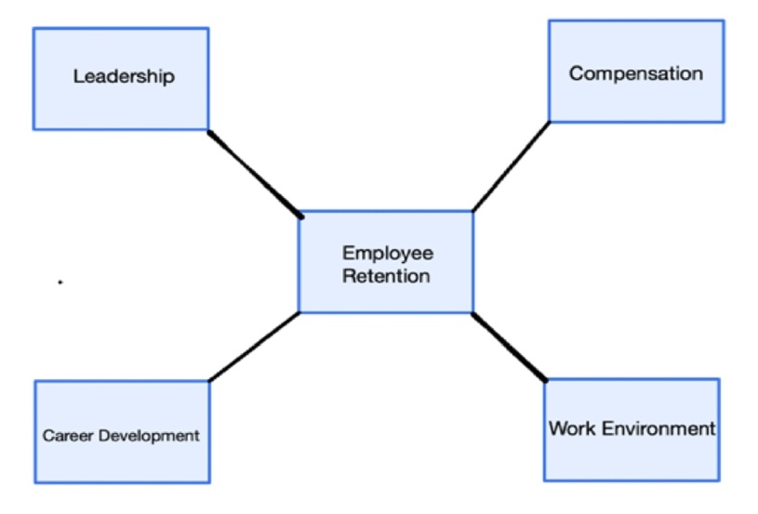
Note: Figure from Key perspectives to enhance employee retention: A study on leadership, compensation, career development, and work environment at ABC company (Feungarrom & Tantasanee, 2025).

Perceived Organizational Support (POS)
POS consistently predicts employee retention because it reflects employees’ beliefs that the organization values them. Eisenberger et al. (1986) emphasized that such perceptions arise from fair rewards, supportive supervision, and safe conditions. Kurtessis et al. (2017) confirmed through meta-analysis that POS strengthens affective commitment and reduces turnover intentions. More recent work also supports this view. For example, William and Fernando (2025) found that enhancing organizational support through welfare initiatives and transparent practices significantly reduced turnover in the Myanmar service sector, demonstrating POS’s applicability across cultural and industrial contexts. However, Herzberg’s framework suggests that many dimensions of POS, such as workplace safety and welfare, are hygiene factors. The critical tension is that while POS fosters loyalty through reciprocity, as explained by Social Exchange Theory (Blau, 1964; Cropanzano & Mitchell, 2005), its effectiveness depends on whether employees interpret support as genuine care or merely compliance with minimum expectations.

Figure 5

Conceptual Framework of Developing Strategies to Enhance Employee Retention at Assumption Learning Loft, Myanmar

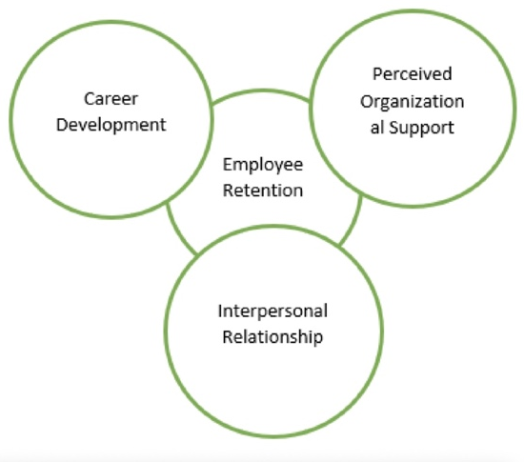
Note: Figure from Developing Strategies to Enhance Employee Retention at Assumption Learning Loft, Myanmar (William & Fernando, 2025).

Conceptual Framework
This framework draws on Organizational Support Theory and Social Exchange Theory to examine five determinants of long-term employee retention: compensation, workload, leadership style, perceived organizational support, and career development. In the context of Hong Zin Tai Industry Company Limited, these factors are critical given its lean workforce, competitive market, and mix of global ownership with local culture. The framework proposes that fair pay, manageable workloads, supportive leadership, organizational care, and visible growth opportunities collectively shape employees’ perceptions of value and commitment. Mapping these domains to qualitative data, the study identifies practices that foster loyalty, engagement, and sustainable retention.

Figure 6

The Conceptual Framework of this study

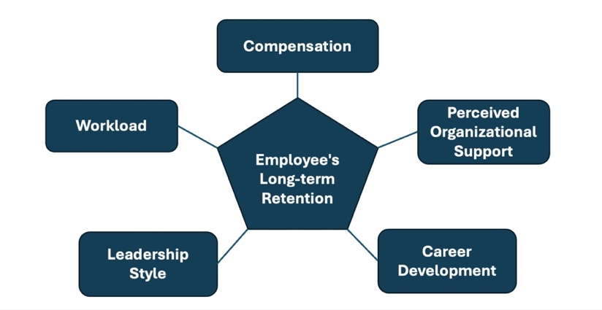
Note: Author’s own illustration (2025)

Research Methodology

Research Design
This study adopts a qualitative, exploratory case study design positioned within an interpretivist paradigm, which assumes that reality is socially constructed and best understood through the subjective experiences of participants (Creswell & Poth, 2018). This approach was selected to generate an in-depth understanding of the factors contributing to long-term employee retention within the production department of the case company. A qualitative methodology is particularly suited to exploring employees’ lived experiences, perceptions, and motivations—dimensions that cannot be adequately captured through numerical data alone.
The inquiry was guided by the Appreciative Inquiry (AI) framework, which emphasizes identifying organizational strengths, shared values, and aspirational visions of the future, rather than focusing exclusively on problems or deficiencies. This strengths-based orientation facilitated constructive dialogue, encouraged the sharing of positive workplace experiences, and elicited practical, employee-driven suggestions for enhancing retention.

Research Instrument
The semi-structured guide was structured around the AI 5D framework. For example, questions in the Define stage clarified participants’ understanding of long-term employment; Discover questions invited them to share positive workplace experiences; Dream questions asked them to articulate their ideal workplace; Design questions elicited concrete suggestions for improvement; and Destiny questions explored motivations for future commitment.

The development of this guide was also informed by a review of relevant literature on employee retention and the theoretical foundations of Organizational Support Theory and Social Exchange Theory. All questions were open-ended, allowing participants to elaborate freely while ensuring that each interview covered the same thematic scope. The semi-structured format enabled the interviewer to probe deeper into emerging topics as they arose, while maintaining comparability across responses. Face validity of the instrument was confirmed through review by the academic advisor, and minor revisions were made before fieldwork.

Research Sampling
This study employed purposive, stratified random sampling within the production department of Hong Zin Tai Industry Company Limited. At the time of data collection, the department comprised 29 employees, the core workforce in pencil manufacturing. This group was chosen because production workers directly experience daily operations, organizational culture, and retention challenges in a small, foreign-invested setting.
Inclusion criteria required current employment in the production unit, without restrictions on age, gender, or shift, ensuring diversity. A roster of all 29 staff was obtained, and a random number generator was used to select eight participants, stratified by gender and tenure. The final sample included both male and female employees, ranging from a few months to over ten years of service. Although four participants had less than one year of tenure, their perspectives were valuable for understanding onboarding experiences, early adjustment, and emerging retention concerns, while mid- and long-tenured employees offered insights into sustained commitment. A sample size of eight was considered sufficient given the group’s relative homogeneity and the likelihood of theme saturation (Guest et al., 2006; Malterud et al., 2015).

Data Collection
Data were gathered through individual, face-to-face interviews with production workers on 22 July 2025 at the company premises, minimizing disruption to work routines. Each interview lasted 15-20 minutes, a duration deemed manageable within working hours while still allowing exploration of all key questions. Although relatively brief, the structured design and focused scope enabled participants to share rich and relevant perspectives, producing adequate depth for thematic analysis.
The interviews were conducted in Thai, the participants’ primary language, to promote comfort and encourage authentic responses. All interviews were audio-recorded with verbal consent from the participants. The recordings were later transcribed verbatim in Thai and then translated into English for coding and analysis. This process ensured both linguistic accuracy and cultural nuance in interpreting participants’ perspectives.

Data Analysis
Data analysis in this study followed a rigorous, multi-stage qualitative approach, designed to ensure credibility, depth, and clear alignment with both the conceptual framework and relevant empirical literature on employee retention.

Preparation and Organization of Data
Following data collection, all interview recordings were transcribed verbatim in Thai to preserve linguistic authenticity and contextual nuance. Transcripts were then translated into English by the researcher, with consultation from a bilingual colleague to ensure accuracy and minimize interpretive bias. This bilingual, iterative process supported both linguistic and conceptual fidelity (Temple & Young, 2004).

Analytical Framework and Rationale
The analysis was guided by the Appreciative Inquiry (AI) 5D framework: Define, Discover, Dream, Design, and Destiny, which was used to structure the coding process. AI was selected because it emphasizes organizational strengths and aspirational goals (Cooperrider & Whitney, 2005), making it well-suited to exploring employees’ perceptions of retention. To complement this, thematic coding was also mapped onto the study’s conceptual framework variables: Compensation, Workload, Leadership Style, Perceived Organizational Support (POS), and Career Development. In this way, both inductive codes (emerging from participants’ narratives) and deductive codes (derived from literature and theory such as Bass & Riggio, 2006; Rhoades & Eisenberger, 2002; Tangthong et al., 2014) were incorporated.

Coding Process and Reliability
Open coding was initially performed independently by three qualitative researchers to maximize analytic rigor and minimize subjective bias. Each coder reviewed the translated transcripts, identifying and labeling significant statements, recurring phrases, and meaningful patterns. Codes were then clustered by consensus into broader thematic categories aligned with both the AI 5D stages and the five variables in the conceptual framework.
Inter-coder reliability was ensured through repeated meetings and collaborative reconciliation of all coding discrepancies, supporting methodological transparency as recommended by Braun and Clarke (2006) and Miles and Huberman (1994). This consensus process helped ensure that emergent findings accurately reflected shared meanings, rather than individual interpretations.

Thematic Development and Link to Literature
Thematic analysis proceeded in stages. First, relevant segments were coded and organized according to AI stages and framework variables. Next, codes were grouped into themes representing Compensation, Workload, Leadership Style, POS, and Career Development. A cross-case comparison was then undertaken to identify differences by tenure, gender, and role. Finally, these themes were interpreted in relation to existing literature. For example, “fair compensation” and “workload manageability” were consistent with findings by Tangthong et al. (2014) and Aqilah et al. (2023) in Southeast Asian manufacturing, while “supportive leadership” and “career development” echoed insights from Feungarrom and Tantasanee (2025) and Bass and Riggio (2006).

Integration with Conceptual Framework
The final set of themes recognized how the five antecedents interact dynamically to shape long-term retention, consistent with Organizational Support Theory and Social Exchange Theory (Blau, 1964; Cropanzano & Mitchell, 2005; Rhoades & Eisenberger, 2002). For instance, evidence of perceived organizational support emerged not only as a direct theme but also as an integrative concept linking leadership, compensation, and career development to retention outcomes. The analysis demonstrated how employees’ perceptions of these factors both reflect and reinforce the reciprocal relationships highlighted in the literature.

Synthesis and Reporting
Synthesized findings were summarized according to the AI 5D framework, with illustrative quotes used to substantiate each major theme. Final results were then interpreted in relation to both the empirical literature and the conceptual framework to highlight theoretical resonance, practical implications, and unique insights specific to the study context.
In summary, this analysis process ensured that participants’ lived experiences were rigorously and transparently translated into academically credible themes, grounded in established literature and theory. The resulting findings provide nuanced, contextually relevant insights into the determinants of long-term retention, supporting both scholarly understanding and practical HR recommendations for the case company.

Results and Discussion

The findings from the qualitative analysis of individual interviews conducted with eight employees from the production department. This aims to provide a clear and systematic presentation of the results concerning the research objectives, the SOAR framework, and the conceptual framework. And the themes presented were developed through a rigorous coding process involving three independent coders, followed by consensus discussions to ensure reliability. The findings are organized to reflect the progression from initial codes to categories, final themes, and their alignment with the study’s theoretical underpinnings.

Participant Profile

Table 1

Participants’ Information

Participant No. | Gender | Years of Work  (In this company) | Current position in Production Department
1 | Female | 11 Months | Production Line Operator
2 | Male | 5 Years | Head of Machinery
3 | Female | 8 Years | Head of Packing
4 | Female | 11 Years | Production Line Operator
5 | Female | 10 Years | Production Line Operator
6 | Male | 6 Months | Warehouse staff
7 | Male | 5 Months | Production Line Operator
8 | Male | 4 Months | Production Line Operator

5Ds Questions and Final Themes

The qualitative analysis was guided by the Appreciative Inquiry (AI) 5D framework: Define, Discover, Dream, Design, and Destiny (Whitney & Trosten-Bloom, 2010). Each dimension was translated into interview questions designed to capture employees’ experiences and aspirations regarding long-term retention. Responses were transcribed, coded, and synthesized into themes reflecting both individual and shared perspectives. Table 2 summarizes this process by aligning each AI dimension with its guiding questions and resulting themes. This approach ensures transparency, linking data collection with thematic interpretation and allowing readers to trace the progression from participant narratives to analytical outcomes.
Table 2

Thematic Analysis of interviews

Dimensions | Questions | Final Themes
Define | How many years have you worked here?  What does it mean to you to stay with a company long time?  What kind of workplace makes you feel safe and willing to stay longer? | Theme 1: Supportive and safe work climate that enables peace of mind  1. Stable, Safe, and Convenient Working Environment  2. Supportive Workplace Culture  3. Fair Compensation and Benefits  4. Manageable Scope of Work with Opportunities for Growth  5. Sense of Belonging and Job Satisfaction
Discover | What do you enjoy the most about working here?  Can you share a positive experience you’ve had while working in this company?  What makes your workday feel satisfying or meaningful? | Theme 2: Supportive teamwork and approachable leadership  1. Supportive and Collaborative Work Environment  2. Approachable and Caring Leadership  3. Fair Compensation and Benefits  4. Manageable and Enjoyable Workload  5. Opportunities for Learning and Growth  6. Positive Work-life Balance
Dream | If you could improve anything about your job or workplace, what would it be?  What kind of workplace do you dream of working in? | Theme 3: Sufficient facilities and safety that meet worker expectations  1. Satisfaction with Current Workplace  2. Safe, Clean, and Comfortable Work Environment  3. Supportive and Respectful Management Culture  4. Reasonable and Manageable Workload  5. Peace of Mind and Job Stability
Design | What do you think the company can do to help employees stay longer?  What kind of support or system would make your job better? | Theme 4: Targeted compensation and practical supports that sustain staying  1. Increased Overtime Opportunities for Higher Income and Growth  2. Supportive and Respectful Work Culture  3. Fair Compensation and Comprehensive Benefits  4. Convenience and Accessibility  5. Peace of Mind and Job Security
Destiny | What keeps you coming to work every day?  What would make you decide to stay with this company for the next 3-5 years? | Theme 5: Peace of mind with manageable work and relational closeness keeps people coming  1. Good Work Environment & Positive Atmosphere  2. Supportive Leadership and Colleagues  3. Manageable Workload & Peace of Mind  4. Fair Compensation & Job Security  5. Convenient Location & Stability  6. Recognition & Motivation Systems

Qualitative Analysis
The Appreciative Inquiry (AI) approach was adopted for its strength-based orientation, enabling the study to highlight organizational assets while identifying opportunities for sustaining engagement. Each dimension offered a lens for analysis: Define captured workplace essence, Discover current strengths, Dream envisioned the ideal environment, Design proposed improvements, and Destiny reflected long-term commitment. Themes were supported by participant insights and linked to key retention variables, compensation, workload, leadership, perceived organizational support, and career development. This integration provided authentic employee perspectives while grounding findings in established retention models.

DEFINE: Understanding the Core of the Workplace Experience
Final Theme: A supportive and safe work climate that fosters peace of mind and belonging.
Interpretation: Participants described the production department as safe, stable, and welcoming, where supportive supervisors and collegial relationships foster trust and comfort. The workplace was perceived as physically secure, clean, and non-hazardous, with fair wages and reliable welfare, all of which promoted a sense of belonging and long-term stability. Psychological comfort, or “peace of mind,” emerged as a decisive retention factor. This reflects Perceived Organizational Support (Eisenberger et al., 1986) and Social Exchange Theory (Blau, 1964), as management’s fairness and approachability reinforced employees’ affective commitment and reciprocal loyalty.

DISCOVER: Positive Aspects of Current Work Life
Final Theme: Collaborative teamwork and approachable, involved leadership.
Interpretation: Cooperation and teamwork were consistently cited as workplace strengths. Colleagues were viewed as collaborative, and supervisors as approachable and actively engaged in daily problem-solving, which reduced stress and enhanced cohesion. These findings reflect the role of Perceived Organizational Support, as accessible leaders who communicate openly reinforce trust and psychological safety (Eisenberger et al., 1986). They also align with Social Exchange Theory, where supportive leadership creates a sense of reciprocity that fosters loyalty and commitment (Blau, 1964; Cropanzano & Mitchell, 2005). From the perspective of Herzberg’s Two-Factor Theory, approachable and fair leadership, together with positive collegial relationships, function as hygiene factors that prevent dissatisfaction and build a stable foundation for retention.

DREAM: Perceptions of the Ideal Workplace
Final Theme: A well-maintained, comfortable, and safe environment that already meets expectations.
Interpretation: Most participants expressed satisfaction with the existing facilities, pointing to recent renovations, safety improvements, and security measures that contributed to both productivity and morale. These conditions were interpreted as signs of organizational care and reinforced employees’ sense of support (Eisenberger et al., 1986). By sustaining comfort and reducing stress, the physical environment not only promoted workload manageability but also reflected Herzberg’s view of hygiene factors, where adequate working conditions prevent dissatisfaction and strengthen the foundation for long-term retention.

DESIGN: Suggestions for Sustaining Retention
Final Theme: Enhanced financial incentives and logistical support to reinforce loyalty.
Interpretation: Employees recommended practical measures such as more overtime opportunities, transportation support, and higher attendance bonuses. These reflect compensation as a retention lever, consistent with Herzberg’s Two-Factor Theory (Herzberg, 1968), where financial rewards act as hygiene factors preventing dissatisfaction. At the same time, tangible supports such as transportation assistance embody POS, reinforcing the reciprocity principle in Social Exchange Theory (Blau, 1964) and strengthening mutual commitment.

DESTINY: Long-Term Commitment Factors
Final Theme: Peace of mind from stability, fair treatment, and manageable work sustains loyalty.
Interpretation: Employees described their long-term commitment as rooted in stable routines, fair treatment, supportive leadership, and proximity to home. Retention was seen as a voluntary, positive choice based on satisfaction with the work environment and alignment with organizational values. These findings reflect the influence of Perceived Organizational Support, where fairness and care strengthen employees’ sense of value (Eisenberger et al., 1986), and Social Exchange Theory, which explains how reciprocal trust and supportive leadership foster loyalty (Blau, 1964; Cropanzano & Mitchell, 2005). In addition, Herzberg’s Two-Factor Theory helps clarify how stability, security, and fair treatment operate as hygiene factors that prevent dissatisfaction and provide the foundation for sustained commitment.

Evolving Retention Drivers Across Career Stages: A Conceptual Framework Perspective
Understanding how retention drivers shift across tenure stages is essential for designing adaptive workforce strategies. Analysis of interviews from Hong Zin Tai’s production department shows that retention factors are dynamic and closely aligned with the study’s framework variables: compensation, workload, perceived organizational support (POS), leadership style, and career development. Examining tenure-based differences provided a more nuanced understanding of how employees experience fairness, support, and stability over time.

Early-Career (0-1 Year): Social Integration and Immediate Comfort
New employees emphasized immediate comfort, interpersonal support, and proximity to home. Feeling welcomed, fairly treated, and supported by supervisors and colleagues shaped early engagement. POS and approachable leadership were central drivers, while workload and advancement concerns were less prominent.

Mid-Tenure (2-5 Years): Equity, Work-Life Balance, and Workplace Climate
Employees focused on fairness and balance. Fair compensation, overtime opportunities, manageable workloads, and a collaborative culture were critical. Compensation, workload, and leadership style became the dominant themes, reflecting stronger concern for equity and work-life balance.

Late-Career (6+ Years): Stability, Trust, and Deep Workplace Relationships
Long-serving employees anchored their retention in stability, reliable pay, and deep trust in management and colleagues. POS and leadership style, expressed through fairness, respect, and consistency, were decisive. Compensation was valued mainly as a signal of security rather than advancement.

Career Development: Contextual Absence
This interview data showed that career development was not perceived as a key factor in retention across any tenure stage. Employees rarely mentioned training, skill development, or promotion opportunities as reasons to stay. Instead, retention was driven by immediate, tangible conditions such as fair compensation, job security, and a supportive climate. This absence is significant, as much of the literature positions career development as central to long-term commitment. The findings highlight a contextual gap between theory and practice in small-scale manufacturing, suggesting that retention strategies must be shaped by employees’ expressed priorities rather than generalized assumptions about career advancement.
Table 3

Mapping Final Themes to Conceptual Framework and Tenure-based Retention Insights

Final Theme | Conceptual Framework Element | Observed Pattern by Years of Service | Retention Insight
Stable, Safe, and Convenient Working Environment | Perceived Organizational Support | Cited consistently across all tenure groups; particularly valued by long-tenured employees (8+ years) | Physical safety, stability, and a clean environment are foundational to sustained retention
Supportive Workplace Culture | Perceived Organizational Support | Strongly emphasized by mid- and long-tenured employees | Trust and mutual respect among colleagues and supervisors enhance workplace attachment
Fair Compensation and Benefits | Compensation | Important for all tenure groups; more critical after five years | Salary fairness and reliable benefits reinforce long-term commitment
Manageable Scope of Work with Opportunities for Growth | Workload + Career Development | Newer employees value low workload stress; mid- and long-term employees focus on growth opportunities | Manageable workload eases integration; career development sustains engagement
Sense of Belonging and Job Satisfaction | Perceived Organizational Support + Leadership Style | Reported across all tenure groups, with stronger emotional attachment in longer service | Emotional connection to the workplace is a significant predictor of long-term retention
Positive Work-life Balance | Workload | More emphasized by mid-tenure employees | Flexible and reasonable schedules help prevent burnout during career progression
Opportunities for Learning and Growth | Career Development | Commonly noted in the 2-5 year tenure range | Development opportunities facilitate transition from short- to long-term retention
Peace of Mind and Job Stability | Perceived Organizational Support + Compensation | Most frequently cited by employees with 8+ years of service | Stability and assurance of continued employment are key long-term retention drivers

Comparative Thematic Analysis by Gender, Tenure, and Position From Table 1
The sample comprised 8 production department employees: 4 females and 4 males. Tenure ranged from 4 months to 11 years, and positions included Production Line Operator, Warehouse Staff, and two supervisory/lead technical roles (Head of Machinery, Head of Packing).

Gender-Based Patterns
Gender differences in retention drivers were minimal. Female participants, including long-tenure operators and one supervisor, emphasized stability, trust in leadership, and supportive team culture. Shorter-tenure women highlighted fairness, safety, and welcoming colleagues during adjustment. Male participants included one mid-tenure supervisor and three newer employees. While the supervisor stressed pay fairness, workload efficiency, and team cohesion, newer males focused on integration, leadership accessibility, and physical work comfort. Overall, women emphasized Perceived Organizational Support (POS) and leadership, while men referenced POS, leadership, and workload.

Tenure-Based Patterns
Tenure was the strongest differentiator. Short-tenure staff (<1 year) prioritized integration, supervision, and safety, with compensation viewed as adequate but secondary. Mid-tenure staff (5-8 years) balanced fair pay, autonomy, workload, and sustaining morale, linking retention to leadership and compensation. Long-tenure staff (10-11 years) highlighted stability, enduring relationships, and loyalty, with compensation framed as security rather than motivation.

Position-Based Patterns
Operators highlighted the importance of immediate conditions such as colleague support, approachable managers, and manageable workloads, while also emphasizing the need for stability in long-tenure cases. Warehouse staff valued collaboration and clarity, which aligned with the themes identified among short-tenure operators. Supervisors stressed the significance of autonomy, leadership presence, and team morale, indicating that empowerment and trust from upper management are key factors for retention at this level.

Integrated Interpretation
Retention drivers converged across gender, tenure, and position. Tenure shaped the strongest differences: newcomers valued integration, mid-tenure staff emphasized fairness and balance, and long-tenure staff prioritized stability and trust. Operators focused on daily conditions, supervisors on empowerment and cohesion. Notably, career development remained absent across all groups, reinforcing its limited salience in this production context.

The Difference
While Career Development is widely supported in retention literature as a critical antecedent (Allen et al., 2003; Feungarrom & Tantasanee, 2025), it did not emerge prominently in the present data. The absence of frequent or strong references suggests that, for production employees at Hong Zin Tai, career growth opportunities are not currently a salient factor in retention decisions. This finding highlights a potential gap between theory and practice, representing an area the organization could strengthen if it wishes to emphasize long-term development pathways.

Summary of Key Findings
- POS, Leadership Style, Compensation, and Workload emerged as consistently important drivers of retention.
- Career Development was notably absent from the core themes, indicating a gap between theory and what employees perceive as relevant.
- Retention drivers shift across tenure stages, moving from integration and comfort to stability and trust.
- Minimal differences observed in this small sample; position affected emphasis but not the overall nature of retention factors.

Research Objective 1:
Employees emphasized genuine organizational support, describing a workplace marked by safety, fairness, and respect. Approachable leadership fostered trust and motivation, while predictable compensation, including wages, bonuses, and overtime, reinforced security. Manageable workloads supported both well-being and effectiveness. Career development received little attention, with most prioritizing stability and positive relationships. These perceptions align with Organizational Support Theory and Social Exchange Theory, where fairness, care, and reciprocity strengthen loyalty and commitment.

Research Objective 2:
SOAR analysis showed management aspired to promote well-being and growth through wellness activities, stress management, and training. Employees, however, stressed immediate needs such as fair pay, stable workloads, and interpersonal support. Career development resonated with some mid-tenure staff but was less relevant to those seeking stability. The findings suggest partial alignment: management emphasizes growth, while employees prioritize security. Stronger retention may require balancing long-term aspirations with current workforce needs.

Research Question 1:
It was mainly influenced by fair pay, manageable workloads, and supportive workplace relationships. Compensation provided stability and fairness, while balanced tasks reduced stress. Perceived Organizational Support, reflected in safety, approachable leaders, and teamwork, deepened attachment. Career development was mentioned, but it was less important. These findings align with Social Exchange Theory’s emphasis on reciprocity, Organizational Support Theory’s focus on care and fairness, and Herzberg’s view of compensation and security as hygiene factors that prevent dissatisfaction.

Research Question 2:
Management’s vision of wellness, training, and mentorship aligned with employees’ appreciation of supportive conditions but diverged in priorities. Employees, especially those with longer tenure, placed greater weight on stable compensation, manageable workloads, and trusted relationships. Retention strategies would be strengthened by addressing immediate needs before expanding career development, reinforcing reciprocity as outlined in Social Exchange Theory.

Conclusions and Recommendations

Maintain and Enhance Competitive Compensation Structures
Compensation is a core retention driver across all tenure stages. Employees described fair pay, bonuses, and overtime as essential for both financial stability and recognition. This reflects the SOAR Strength of Competitive Compensation and the Aspiration of employee well-being, as income security builds trust and reduces turnover. Maintaining competitive salaries, ensuring transparent pay structures, and introducing targeted incentives such as transport or skill-based bonuses will address immediate needs while reinforcing loyalty, consistent with Social Exchange Theory.

Strengthen Workload Management to Support Long-Term Well-being
Employees consistently emphasized the importance of fair and predictable workloads. Lighter demands supported newcomers, while mid- and long-tenure staff highlighted balanced task distribution and realistic scheduling. These findings align with SOAR Opportunities in performance management and the Aspiration of well-being. Implementing planning systems, clear productivity standards, and regular workload reviews will reduce stress, sustain morale, and increase retention, directly supporting the Result of lower turnover.

Enhance Perceived Organizational Support (POS) to Strengthen Loyalty and Engagement
POS strongly influenced loyalty. Employees valued safe and clean facilities, welfare benefits, open communication, and visible engagement from management. These reflect SOAR Aspirations for well-being and Results in reduced turnover. Strengthening POS through regular feedback sessions, non-financial recognition, and timely responses to concerns will demonstrate genuine care, fulfilling the reciprocity principle in Social Exchange Theory and reinforcing long-term commitment.

Foster Leadership Practices that Build Trust and Stability
Leadership style shaped employees’ workplace experience. Approachability, fairness, and respect were key for all tenure stages, with new staff valuing guidance and long-serving staff stressing consistency. This aligns with SOAR Aspirations of a Growth-Focused Workplace and sustaining commitment. Leadership programs should prioritize communication, listening, fairness, and participatory decision-making, complemented by mentorship and informal interactions to strengthen trust and morale.

Address Career Development Gaps to Enhance Engagement
Career development was not a major retention factor, though some mid-tenure staff valued learning opportunities. This gap presents a strategic opportunity aligned with SOAR Aspirations for growth and Results in sustainable success. Structured training, mentorship, cross-training, and transparent promotion pathways can gradually shift perceptions, linking career growth to fairness and adaptability. Over time, this will strengthen retention and organizational resilience.

Summary of Recommendations
The recommendations derived from this study directly connect employee perceptions with management aspirations identified through the SOAR analysis. They emphasize strengthening compensation fairness, workload manageability, organizational support, and leadership practices while addressing gaps in career development. This integrated approach ensures that strategies are rooted in employees’ lived experiences while also supporting management’s goals of fostering well-being and long-term growth. By aligning immediate workforce needs with aspirational objectives, the recommendations provide a coherent pathway for reducing turnover and sustaining a stable, engaged workforce that supports organizational success.

Limitations
This study provides insights into retention among Thai production workers at Hong Zin Tai Industry Company Limited, but several limitations should be acknowledged. Conducting research within a single company limits generalizability, as cultural or leadership differences elsewhere may yield different results. The qualitative, self-reported design may also be influenced by social desirability bias. In addition, the cross-sectional approach captured perspectives at one point in time, without reflecting how priorities may shift. The focus on production staff excluded administrative and managerial employees whose retention drivers could differ. Finally, translation from Thai to English, despite careful review, may have altered nuances. Future research should adopt multi-site, longitudinal, and mixed-method designs with broader participant groups.

Suggestions for Future Research
This study focused on production workers at Hong Zin Tai Industry Company Limited, exploring best practices for retention and the alignment between employee perceptions and management aspirations. Future research could extend to comparative studies across multiple manufacturing firms in Thailand to capture broader retention trends. Mixed-method designs combining qualitative interviews with quantitative measures would also clarify the relative impact of compensation, workload, and organizational support. Further studies could examine administrative staff, supervisors, and management to identify overlaps or gaps in priorities. Longitudinal research would be valuable in assessing changes in perceptions over time, while deeper exploration of career development and upskilling may reveal opportunities to better align organizational aspirations with evolving workforce expectations.

References

Allen, D. G., Shore, L. M., & Griffeth, R. W. (2003). The role of perceived organizational support and supportive human resource practices in the turnover process. Journal of Management, 29(1), 99-118. https://doi.org/10.1177/014920630302900107
Aqilah, Q., Nursal, A. T., Osman, A. A., Rahimi, M., & Bin, I. (2023). The effects of perceived work overload on organizational commitment on employee turnover intention in automotive industry in Pahang. Journal of Technology and Operations Management, 18(1), 33-48.
Bass, B. M., & Riggio, R. E. (2006). Transformational leadership PDF. Scribd. https://www.scribd.com/document/41998558/Transformational-Leadership
Blau, P. M. (1964). Exchange and power in social life. Wiley.
Braun, V., & Clarke, V. (2006). Using thematic analysis in psychology. Qualitative Research in Psychology, 3(2), 77-101. https://doi.org/10.1191/1478088706qp063oa
Bushe, G. R., & Kassam, A. F. (2005). When is appreciative inquiry transformational? A meta-case analysis. Journal of Applied Behavioral Science, 41(2), 161-181.
https://doi.org/10.1177/0021886304270337
Cooperrider, D. L., & Whitney, D. (2005). Appreciative inquiry: A positive revolution in change. Berrett-Koehler Publishers.
Creswell, J. W., & Poth, C. N. (2018). Qualitative inquiry and research design: Choosing among five approaches (4th ed.). SAGE Publications.
Cropanzano, R., & Mitchell, M. S. (2005). Social exchange theory: An interdisciplinary review. Journal of Management, 31(6), 874-900. https://doi.org/10.1177/0149206305279602
Eisenberger, R., Huntington, R., Hutchison, S., & Sowa, D. (1986). Perceived organizational support. Journal of Applied Psychology, 71(3), 500-507.
https://doi.org/10.1037/0021-9010.71.3.500
Feungarrom, P., & Tantasanee, S. (2025). Key perspectives to enhance employee retention: A study on leadership, compensation, career development, and work environment at ABC company. ABAC ODI Journal Vision. Action. Outcome, 12(2), 109-124.
Guest, G., Bunce, A., & Johnson, L. (2006). How many interviews are enough? An experiment with data saturation and variability. Field Methods, 18(1), 59-82.
https://doi.org/10.1177/1525822X05279903
Haddad, H., El Khatib, N., & Ashaal, A. (2023). The nexus between extrinsic motivation and employees’ retention: Do compensation packages and flexible working hours matter? Open Journal of Business and Management, 11(2), 530-551.
https://doi.org/10.4236/ojbm.2023.112030
Herzberg, F. (1968). Work and the nature of man. World Publishing.
Kurtessis, J. N., Eisenberger, R., Ford, M. T., Buffardi, L. C., Stewart, K. A., & Adis, C. S. (2017). Perceived organizational support: A meta‐analytic evaluation of organizational support theory. Journal of Management, 43(6), 1854-1884.
https://doi.org/10.1177/0149206315575554
Malterud, K., Siersma, V. D., & Guassora, A. D. (2015). Sample size in qualitative interview studies: Guided by information power. Qualitative Health Research, 26(13), 1753-1760. https://doi.org/10.1177/1049732315617444
Miles, M. B., & Huberman, A. M. (1994). Qualitative data analysis: An expanded sourcebook (2nd ed.). SAGE Publications.
Nickerson, C. (2025). Herzberg’s Two-Factor Theory of Motivation-Hygiene. Simply Psychology. Simply psychology.
https://www.simplypsychology.org/herzbergs-two-factor-theory.html
Rhoades, L., & Eisenberger, R. (2002). Perceived organizational support: A review of the literature. Journal of Applied Psychology, 87(4), 698-714.
https://doi.org/10.1037/0021-9010.87.4.698
Tangthong, S., Trimetsoontorn, J., & Rojniruntikul, N. (2014). HRM practices and employee retention in Thailand—A literature review. International Journal of Trade, Economics and Finance, 5(2), 162-166. https://doi.org/10.7763/IJTEF.2014.V5.362
Temple, B., & Young, A. (2004). Qualitative research and translation dilemmas. Qualitative Research, 4(2), 161-178. https://doi.org/10.1177/1468794104044430
Whitney, D., & Trosten-Bloom, A. (2010). The power of appreciative inquiry: A practical guide to positive change (2nd ed.). Berrett-Koehler.
William & Fernando, M. (2025). Developing strategies to enhance employee retention at Assumption Learning Loft, Myanmar. ABAC ODI Journal Vision. Action. Outcome, 12(2), 90-108.
Xuecheng, W., Johnson, R. D., & Tuckey, M. (2022). Factors affecting employee retention: Integration of situational leadership with social exchange theory. Frontiers in Psychology, 13, 872105. https://doi.org/10.3389/fpsyg.2022.872105

